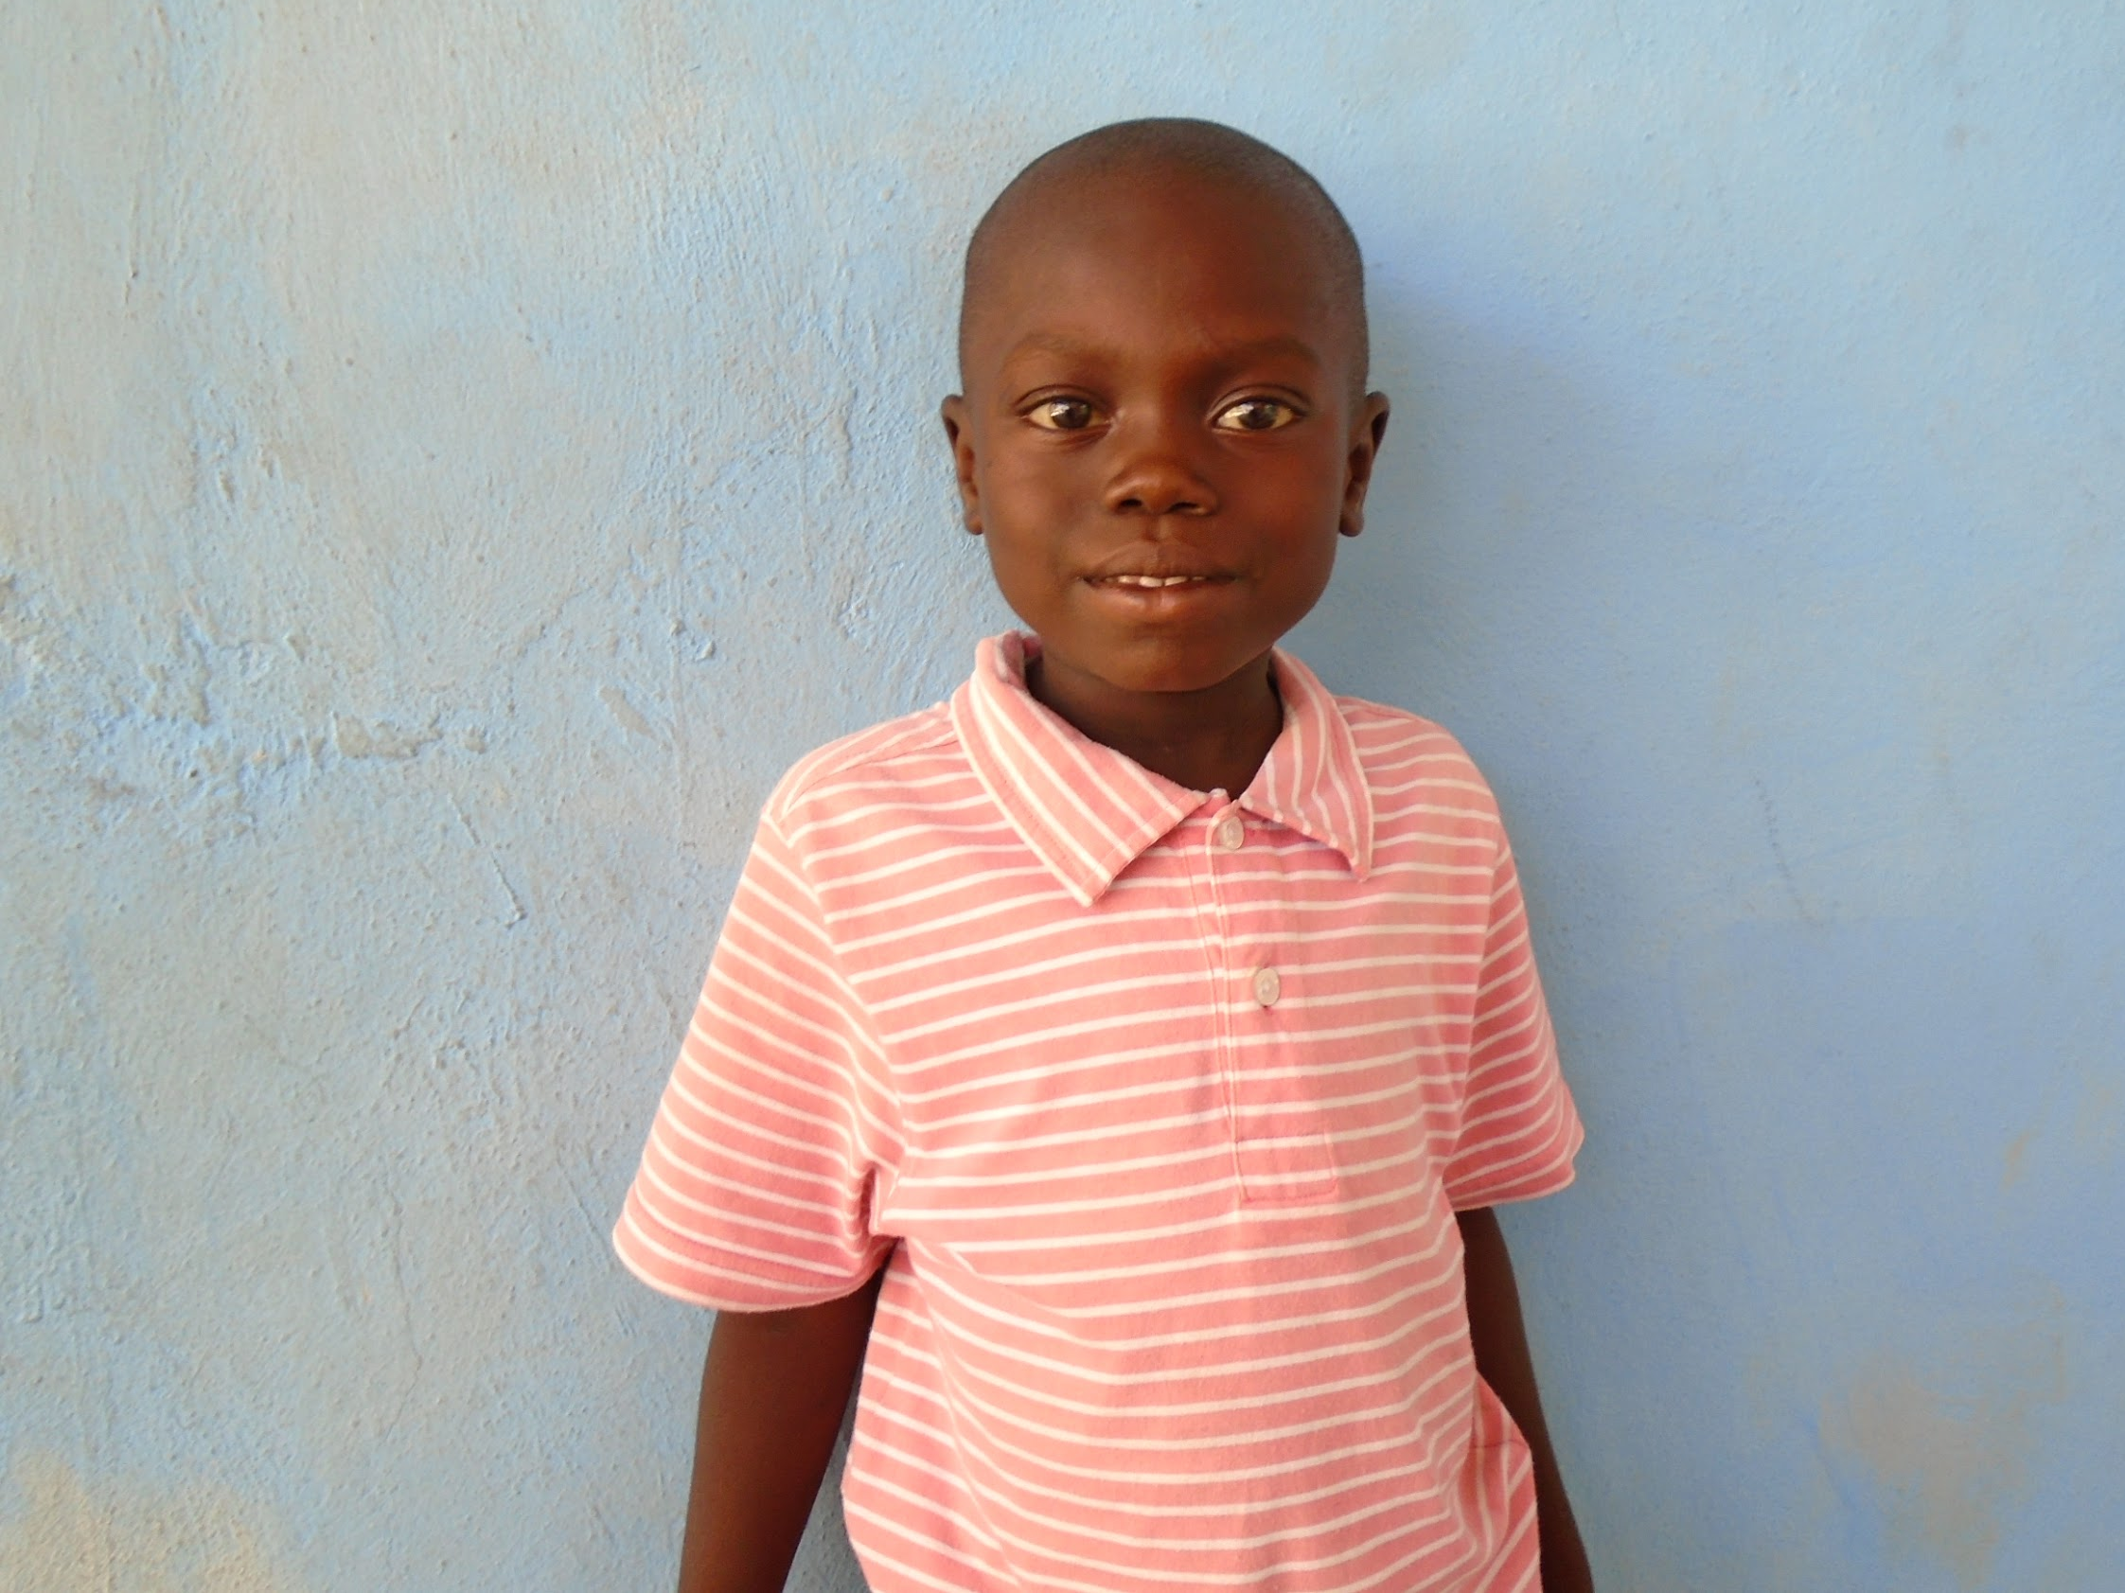

SPONSORED CHILD UPDATE

CHILD NAME:Woodnelson Destil DATE: August 29, 2017

SPONSOR NUMBER: 2015-00-011J
SCHOOL: Johel HEIGHT: __42”_______ SIZE__kids 5______
GRADE:1st WAIST ___21”_________
AGE: 5yr CHEST: __22”_______
HIPS_____23”_____
BOYS: PANTS INSEAM ___23”____
FOOT LENGTH_7”______ SHOE SIZE:__kids 13____
WHO IS LIVING IN YOUR HOUSE AND WHAT ARE THEIR AGES?
Twelve people: mom, dad, ten brothers and sisters.

WHAT ARE YOUR FAMILY NEEDS? (HOW CAN SPONSOR PRAY?)
Please pray that my family would be able to have jobs.

DO YOU ATTEND CHURCH? IF SO, WHICH CHURCH?
Yes, we go to MEBEA.

DOES YOUR FAMILY HAVE A BIBLE?
Yes, we have a Bible.

WHO CAN READ IN YOUR FAMILY?
My brothers and sisters, but not the little ones.

WHAT DO YOU BELIEVE ABOUT GOD, JESUS, THE HOLY SPIRIT?
God loves everyone. Jesus loves little children.

WHAT IS A TYPICAL DAY LIKE FOR YOU?
I wash my face, sweep the yard, cook, and go to the garden.

WHAT WOULD YOU LIKE TO SAY TO YOUR SPONSOR?
I love you very much! Bonswa (good afternoon). I am praying for you.

