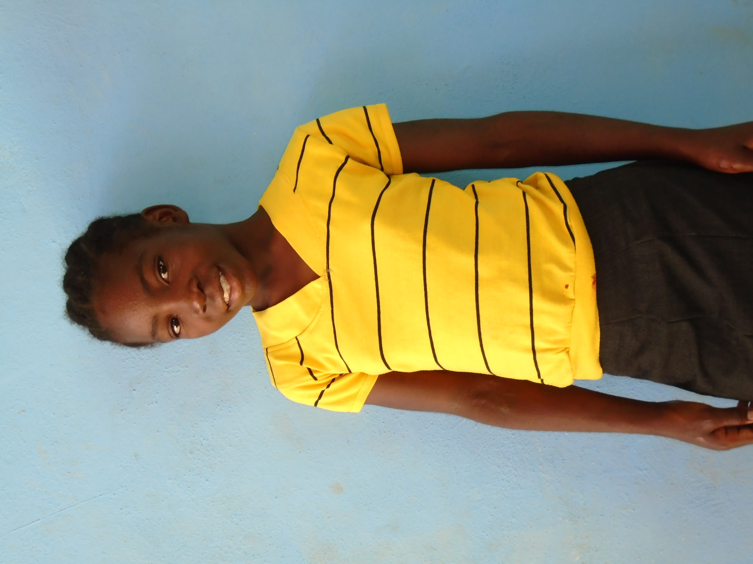

SPONSORED CHILD UPDATE

CHILD NAME: Duna Gabriel DATE: August 29, 2017

SPONSOR NUMBER: 2016-00-180J
SCHOOL: Johel HEIGHT: _51________ SIZE_girls 12_______
GRADE: 3rd WAIST ___27_________
AGE: 10yr CHEST: __29_______
HIPS____27______
BOYS: PANTS INSEAM _______
FOOT LENGTH__8.5”_____ SHOE SIZE:_kids 4_____
WHO IS LIVING IN YOUR HOUSE AND WHAT ARE THEIR AGES?
6 people: Aunt, cousins, sister, and I live in our house.

WHAT ARE YOUR FAMILY NEEDS? (HOW CAN SPONSOR PRAY?)
Please pray for our family to continue to have food.

DO YOU ATTEND CHURCH? IF SO, WHICH CHURCH?
Yes, we attend the church at the Hope Center.

DOES YOUR FAMILY HAVE A BIBLE?
Yes.

WHO CAN READ IN YOUR FAMILY?
Everyone but my aunt can read.

WHAT DO YOU BELIEVE ABOUT GOD, JESUS, THE HOLY SPIRIT?
I believe that God is good.

WHAT IS A TYPICAL DAY LIKE FOR YOU?
I wash my face, brush my teeth, and do my homework.

WHAT WOULD YOU LIKE TO SAY TO YOUR SPONSOR?
Thank you very much, and I love you!

